1. Commercial Proposal for
Reference Access and Interconnection Offer Sub Annex C-FA 08 Wholesale Transmission
Table of Contents

1 General 3
2 Definitions 4
3 Transmission Service 5
4 Terms and Conditions 7
5 Database 9
6 Ordering and Delivery 10
7 Tariff 11
8 Fault Management 12
9 Forecasts 13

General
  - This Sub Annex sets out the Omantel offer for Transmission Service.
  - Omantel through this access Service enables bi-directional capacity transmission between Omantel’s Network and the Requesting Party’s Network.
  - Both Parties shall agree on the traffic type that shall be carried by the Transmission Links.

Definitions
  - The definitions in Annex L shall apply to this Sub Annex C-FA 08 in addition to the following definitions:
    - Point of Access – the interface on any Party Network that is used to access its Network.
    - Contract Term – the contract period of the Service provisioning starting from the Service provisioning date.
    - Transmission Links – links that carries the capacity requested by the Requesting Party.

Transmission Service
  - Omantel offers the Requesting Party the possibility to have connectivity between two Points of Access for Access purposes through the Transmission Service.
  - Type A: Omantel offers the Requesting party the possibility to have connectivity between a Point of Access in the Requesting Party’s Network and another Point of Access in the Omantel Network. The Requesting Party’s Point of Access will be in Omantel’s premises.

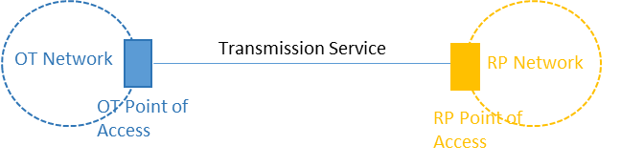
Figure ‎3-1 Transmission Service Type A

    - This Service (Type A) can also be offered on an in-span basis.
    - The two end points of this Service (Type A) can be within the same exchange or in different exchanges.
  - Type B: Omantel offers the Requesting party the possibility to have connectivity between two Points of Access in the Requesting Party’s Network. In this case, the Service will be ordered and delivered as a combination of two times the Terminating segment of leased line (C-FA 10) and a Trunk segment of leased line (C-FA 11) as shown below. This Service could be used to connect the Requesting Party mobile switch to the Requesting Party base station using capacity in Omantel’s network.

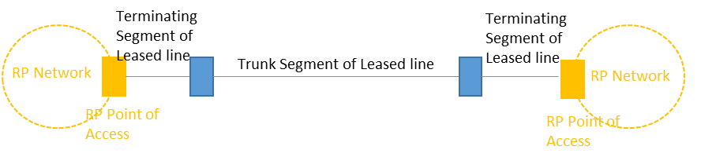
Figure ‎3-2 Transmission Service Type B

  - Type C: Omantel offers the Requesting party the possibility to have connectivity between two Points of Access in Omantel Network. In this case, the Service will be ordered and delivered as a combination of two times the Terminating segment of leased line (C-FA 10) and a Trunk segment of leased line (C-FA 11) as shown below. This service could be used by the Requesting Party to extend its connectivity from one POI location to another.
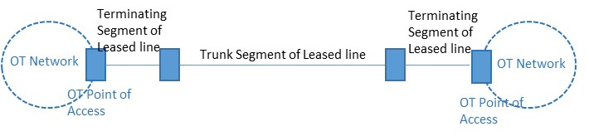
Figure ‎3-3 Transmission Service Type C
  - The Wholesale Transmission service portfolio consists of the following bandwidths
- 2 Mbit/s (E1)
- 34 Mbit/s (E3)
- 155 Mbit/s (STM1)
  - Omantel may be able to provide other bandwidths on terms and conditions agreed between both Parties, depending on technical feasibility and/ or based on the Services requested. Such special requests shall be handled according to Annex H. Such cases will be dealt with on a case-by-case basis against mutually agreed timelines and charges and Omantel shall inform the TRA accordingly and obtain the necessary approvals from it.
  - Omantel offers a Point of Access in Omantel Premises where the Requesting Party shall request Colocation Services from Omantel.
  - Interconnection links
    - Omantel also offers interconnection to both its fixed and mobile networks, the following three variants of Interconnection links namely:
  - In-Building Interconnect (IBI) – this is same as a Type A link with both the Points of Access in the same Omantel premises.
  - Customer Sited Interconnect (CSI) – this is same as a Type A link with one Point of Access in Omantel premises and the other in Requesting Party premises.
  - In-Span Interconnect (ISI) – this is same as a Type A link with one Points of Access in Omantel exchange and the other Point of Access at a meet me point agreed between both parties.

Terms and Conditions
  - Service Provisioning:
    - The Transmission Service shall be subject to technical feasibility.
    - Omantel shall remain the owner of the Transmission Links. The Requesting Party shall not assign, transfer, lease, resell, or share their interest in the Service with any Third Party Operator.
    - Omantel will be responsible to maintain the Transmission Links and shall ensure that the Services offered to the Requesting Party are at the same level of quality as those to Omantel’s own Customers.
  - The Requesting Party Responsibility:
    - The Requesting Party shall request the Transmission Service specifying the details of the request.
    - The Requesting Party shall pay Omantel the charges specified in Clause ‎7 below.
    - The Requesting Party shall physically terminate the Transmission Links on its own node after it is handed over by Omantel.
  - Change request to existing link
    - Upgrading the bandwidth orders are placed according to order procedures in Clause ‎6 of this Sub Annex.
    - The monthly fees for the increased bandwidth will be applicable from the date that the upgrade is performed.
    - A new Contract Term will be applicable for the upgraded link and the existing Contract Term will be cancelled without any early termination charges provided that the new Contract Term at least covers the remaining period of the cancelled Contract.
    - Changes other than upgrading the bandwidth shall be considered as a termination of the Service and an Order of a new one. A downgrade of no more than 5% of the relevant capacity provided to the Requesting Party within the relevant minimum contract period shall be acceptable and shall not be treated as termination of the service. For the avoidance of doubt, a downgrade after the minimum contract period has expired shall not require a termination and reorder.
  - Contract Terms and Termination:
    - The minimum Contract Term is one (1) Year.
    - If either Party wishes to terminate the contract after the completion of the Contract Term, it shall inform the other party, in writing, three (3) months before the completion of Contract Term, of its intent to terminate the Contract. The Requesting Party shall be responsible of the consequences if it terminated the Service with active Customer on his network. The Providing Party shall not terminate the Contract without the prior approval of the TRA.
    - If no notice is provided at least three (3) months before the completion of Contract, the Contract will be automatically renewed with the same Contract Term.
    - Omantel has the right to suspend the Service in accordance with Clause 17 of the Main Agreement in case the Requesting Party is in breach of its obligation under this Agreement.
    - Termination of the Service by the Requesting Party before the expiration of the Contract Term is subject to early Termination Fee equal to the charges of the remaining period of the Contract Term.
    - The termination will be in accordance with the procedures in Annex H.

Database
  - Omantel will install and keep updated a database consisting of all active and ordered Transmission Links of the Requesting Party. The database will consist of at least the following parameters:
- Operator Name
- actual bandwidth
- Operator address
- order date
- agreed and promised delivery date
- actual delivery date
- reported faults
- maintenance actions taken
- installation fee
- monthly fee
  - The Requesting Party shall keep updated a database consisting of all active and ordered Transmission Links. The database shall contain all necessary information that will allow both Parties to reconcile accounts for charging purposes.

Ordering and Delivery
  - Ordering and delivery is handled according to Annex H in addition to the following.
  - Omantel shall target a delivery time of 45 Working Days subject to feasibility, cooperation of the Requesting Party and any other third Party. This delivery date is subject to feasibility, cooperation of the Requesting Party and any other third Party and that there will be no delays caused by factors outside Omantel’s control such as, for example, due to the delay arising from the involvement of governmental entities.
  - The Requesting Party in respect the Wholesale Transmission Service orders may only request the Service once every week on a week day agreed between both Parties.
  - Omantel shall inform the Requesting Party once the link is activated. The Requesting Party shall test the link within 3 Working Days and return back to Omantel during the same period for any issues otherwise Omantel has the right to charge the Requesting Party from the Order Delivery Date.
  - If Omantel rejects the request, Omantel shall inform the Requesting Party on the reasons, which shall be objectively justifiable such as technical feasibility problems.

Tariff
  - The up to date tariff for the Services can be found in Annex M of the Reference Offer.
  - The cost of additional product features, specialized billing, systems and/or network interfaces, non-standard connectivity and associated configuration, integration and testing are not included in the published tariffs. Such cases will be dealt with on a case-by-case basis against mutual agreed timelines and charges. Omantel shall inform the TRA accordingly, and obtain the necessary approvals from it. For the avoidance of doubt, the cost of integration and testing of standard orders is included in the published NRC/set-up fee for the corresponding service and any such charges shall apply to items that could not reasonably be foreseen or in respect to special requirements from the Requesting Party during the provisioning of the services.

Fault Management
  - Fault Management is handled according to Annex H in additional to the following Services.
  - The Requesting Party shall ensure to carry out the initial tests in respect of any fault in customer connection in order to validate that the fault is not from the Requesting Party Network. In case the fault is not at the Requesting Party Network, the Requesting Party shall make available all reasonable and complete test details when reporting the fault to Omantel.
  - In case no fault is found from Omantel’s side, the Requesting Party shall compensate Omantel for all reasonably incurred costs to investigate the fault, which Omantel shall be able to substantiate on request.

Forecasts
  - Forecasting shall be handled according to Annex F.

