1. Commercial Proposal for
Reference Access and Interconnection Offer Sub Annex C-FA 01 Local Loop Unbundling
Table of Contents

1 General 3
2 Definition 4
3 Local Loop Unbundling 5
4 Terms and Conditions 8
5 Database 11
6 Ordering and Delivery 12
7 Tariff 14
8 Fault Management 15
9 Forecasts 16

General
  - This Sub Annex sets out the Omantel offer for Local Loop Unbundling Service.
  - Omantel through this fixed wholesale access Service will enable the Requesting Party to access Customer location through Omantel’s existing copper connectivity to the Customer premises.

Definition
  - The definitions in Annex L shall apply to this Sub Annex in addition to the following definitions:
    - Contract Term – the contract period of the Service provisioning starting from the Service provisioning date.
    - Local Loop – the copper connectivity between the Customer premises to the closest Omantel MSAN.
    - MSAN - Multi-Service Access node – Telecommunication device that connects Customers’ telephone lines to the core Network to provide voice and data Services.
    - MDF Strip – Multiple number of strips that composes an MDF block. Each strip can connect up to 10 Customers.
    - Region – is the Region in the Territory defined by the Authorities.

Local Loop Unbundling
  - Omantel offers the Requesting Party the possibility to access the Customer premises using Omantel’s existing copper pairs.
  - The purpose of this Service is to enable the Requesting Party to offer Services to the local Customers in Oman for their connectivity needs within the Territory.
  - The Omantel copper pair will be disconnected from Omantel’s MSAN and reconnected to the Requesting Party’s cable.
  - Omantel MSANs are either located inside or outside Omantel exchanges.
    - For MSANs outside the exchange, the Service will be offered as described in Figure ‎3-1 below and based on the following conditions:
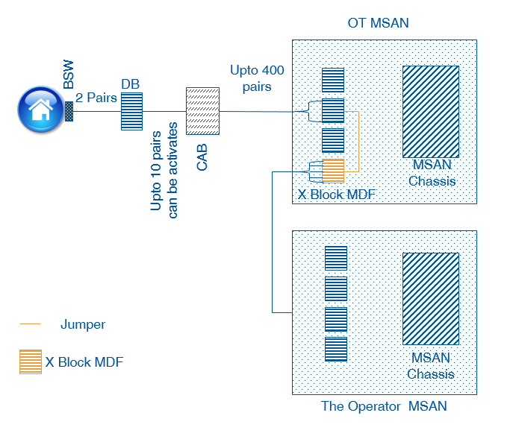
Figure ‎3-1 Local Loop Unbundling (MSAN outside the exchange)
      - The Requesting Party shall place its MSAN adjacent to Omantel’s MSAN;
      - The Requesting Party shall Request at least one MDF Strip in the Omantel MSAN. This Strip will be used as the primary strip for the Requesting Party connection.
      - The Requesting Party shall extend its cable to Omantel’s MSAN and terminate it into the MDF Strip as requested. The Requesting Party shall ensure that no cable/ pairs hang out in the MSAN. This means that the Requesting Party shall extend the exact number of pairs that will terminate in the strip on the day of Request.
      - Upon receiving the Request to connect a Customer, Omantel will connect a cable (jumper wire) between the requested point on the primary strip requested by the Requesting Party and the secondary strip that has connectivity to the specified Customer.
      - In this case, the Customer access is fully separated from Omantel’s MSAN and disconnected from its core Network and therefore Omantel will not be entitled to provide any other Services to the Customer.
      - The Requesting Party will be responsible for all required permits to place its MSAN and extend the connection between its MSAN and Omantel MSAN.
      - The Requesting Party shall be responsible for the provision of appropriate MDF Tie-cables between Omantel’s and the Requesting Party’s MSANs.
      - The Requesting Party shall be responsible for the installation of ducts required to pull the Tie-cables and the termination of the copper pairs on each end of the Tie-cable.
      - The Requesting Party will be responsible for its own Power connectivity to its MSAN.
    - For MSANs inside Omantel exchanges, the Service will be offered as described in diagram Figure ‎3-2 below and based on the following condition:
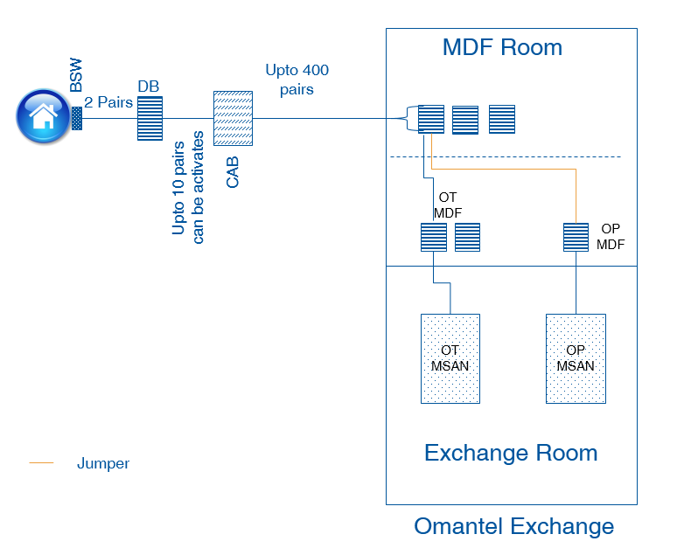
Figure ‎3-2 Local Loop Unbundling (MSAN inside the exchange)
      - The Requesting Party shall request a co-location Service from Omantel as described in Sub Annex C-FA 04. The Requesting Party shall co-locate his MSAN and his MDF at the co-location space.
      - Upon receiving the request to connect a Customer, Omantel will connect a cable (Jumper wire) between the Requesting Party MDF and Omantel MDF that has connectivity to the specified Customer.
      - The Customer access is fully separated from Omantel’s MSAN and disconnected from Omantel’s core Network so that Omantel will not be entitled to provide any other Services to the Customer.
  - For MSANs not inside Omantel exchanges or on the street outside the exchange, the Service provisioning scenario shall be evaluated upon receiving the Request.

Terms and Conditions
  - Service Provisioning:
    - The Local Loop Unbundling provision shall be subject to feasibility.
    - The Local Loop Unbundling will be offered in locations where Omantel has the end to end connectivity to the Customer premise and it is subject to resources availability.
    - Omantel shall offer the Local Loop of those Customers who have paid in full their outstanding dues for this Service acquired from Omantel. Omantel may refuse to provide such a Service where the Customer has any amount outstanding for this specific Service to Omantel, however for the avoidance of doubt, even if Omantel exercises its discretion to provide the Service to an end Customer, this is without prejudice to its right to pursue a claim for the amount due from the end Customer.
    - Omantel shall remain the owner of the Local Loop. The Requesting Party shall not assign, transfer, lease, sell, resell or share their interest with any Third Party Operator.
    - Omantel will be responsible to maintain the Local Loop and shall ensure that the Services offered to the Requesting Party are at the same level of quality as those to Omantel’s own Customers.
    - Left blank
    - Omantel shall not be responsible for any work within the boundary of the Customer’s premises.
    - Omantel shall not be responsible for the quality of the Service offered by the Requesting Party to the Customer through Omantel’s Local Loops due the Local Loop length.
    - Any Service that will be provided by the Requesting Party shall be based on the condition of the copper to be unbundled. Omantel shall not modify its copper network to provide a higher bandwidth beyond or above prequalified capacity of the copper pair to be unbundled.
  - The Requesting Party’s Responsibility:
    - The Requesting Party shall submit with its Local Loop Request a copy of the Customer application form duly completed and signed by the Customer. The Request shall contain all necessary information about the Customer including but not limited to, the Customer details, the connectivity points and his connectivity requirement. The Requesting Party shall also provide a “No Objection” letter from the former Service provider (Third Party Operator excluding Omantel) in case the Customer is an active customer.”
    - The Requesting Party shall be responsible for availability and quality of the Service offered to its Customer.
    - The Requesting Party shall be responsible to invoice and collect the outstanding dues from its Customers.
    - The Requesting Party shall pay Omantel the charges specified in Clause ‎7 below even if the Customer has not paid his dues to the Requesting Party.
    - The Requesting Party shall setup a call center to address all complaints from his Customer.
  - Changing Location
    - All changes to the location of the Local Loop will be considered as a termination of the Service and an order of a new one.
  - Contract Terms and Termination:
    - MSAN to MSAN Connectivity:
      - The minimum Contract Term of the MSAN to MSAN connectivity is one (1) year.
      - If either Party wishes to terminate the contract after the completion of the Contract Term, it shall inform the other Party, in writing, three (3) months before the completion of Contract Term, of its intent to terminate the Contract. The Requesting Party shall be responsible of the consequences if it terminated the Service with active Customer on his network. The Providing Party shall not terminate the Contract without the prior approval of the TRA.
      - If no notice is provided at least three (3) months before the completion of Contract, the Contract will be automatically renewed for the same Contract Term.
    - Local Loop Connectivity:
      - The minimum Contract Term of the Customer local Loop is one (1) year.
      - If either Party wishes to terminate the contract after the completion of the Contract Term, it shall inform the other party, in writing, one (1) month before the completion of Contract Term of its intent to terminate the Contract. The Providing Party shall not terminate the Contract without the prior approval of the TRA.
      - If no notice is provided at least one (1) month before the completion of Contract, the Contract will be automatically renewed on monthly rolling basis.
  - Omantel has the right to suspend the Service in accordance with Clause 17 of the Main Agreement in case the Requesting Party is in breach of its obligation under this Agreement.
    - Termination of the Service by the Requesting Party before the expiration of the Contract Term is subject to an early Termination Fee equal to the charges of the remaining period of the Contract Term.
    - The Requesting Party can terminate the Contract upon the request from the Customer without the Termination Fee if the Customer requested the Service from Omantel directly or through any Third Party Operator.
    - The termination will be in accordance with the procedures in Annex H.

Database
  - Omantel will install and keep updated a database consisting of all active and ordered Local Loops. The database will consist of at least the following parameters:
- Customer Name
- Customer contact number
- Customer address
- Services subscribed
- order date
- agreed and promised delivery date
- actual delivery date
- reported faults
- maintenance actions taken
- installation fee
- monthly fee
- discount schemes applicable to the line
  - The Requesting Party shall keep updated a database consisting of all active and ordered Local Loops. The database shall contain all necessary information that will allow both Parties to reconcile accounts for charging purposes.

Ordering and Delivery
  - Ordering and delivery is handled according to Annex H in addition to the following Clauses.
  - With respect to connectivity between the Requesting Party’s MSAN and Omantel’s MSAN, Omantel shall target a delivery time of 45 Working Days subject to feasibility, cooperation of the Requesting Party and any other third Party. This delivery date is subject to the Requesting Party and/or the end user having fully cooperated with Omantel and that there will be no delays caused by factors outside Omantel’s control such as, for example, due to the delay arising from the involvement of governmental entities. However, in case more than one MSAN connectivity is requested during the same period, the Parties shall negotiate and agree on an implementation plan.
  - The Requesting Party shall request the Local Loop of only those Customers who are connected to Omantel’s MSAN which is already connected with the Requesting Party’s Network.
  - With respect to a Local Loop Order, Omantel shall target a delivery time of 30 Working Days subject to feasibility, cooperation of the Requesting Party and/ or his customer and any other third Party. This delivery date is subject to the Requesting Party and/or the end user having fully cooperated with Omantel and that there will be no delays caused by factors outside Omantel’s control such as, for example, due to the delay arising from the involvement of governmental entities.
  - The Requesting Party in respect of the Local Loop Orders may only request the Service once every week on a week day agreed between both Parties. Both Parties shall agree on the number of connections the can be submitted at each time.
  - Omantel technicians jointly with the Requesting Party’s technicians shall connect and test the Local Loop of the Customer.
  - The Requesting Party’s Network should be ready with the Service provisioning to the Customer before Omantel and the Requesting Party teams jointly connect the Customer. This will ease testing the Service.
  - If Omantel rejects the request, Omantel shall inform the Requesting Party of the reasons which shall be objectively justifiable such as technical feasibility problems.

Tariff
  - The up to date tariff for the Services can be found in Annex M.
  - The cost of additional products features, specialized billing, systems and/or Network interfaces, non-standard connectivity and associated configuration, integration and testing are not included in the published tariffs. Such cases will be dealt with on a case-by-case basis against mutual agreed timelines and charges. Omantel shall inform the TRA accordingly, and obtain the necessary approvals from it. For the avoidance of doubt, cost of integration and testing of standard orders is included in the published NRC/set-up fee for the corresponding service and any such charges shall apply to items that could not reasonably be foreseen or in respect to special requirements from the Requesting Party during the provisioning of the services.

Fault Management
  - Fault Management is handled according to Annex H in additional to the following Clauses.
  - The Requesting Party shall carry out the initial tests in respect of any fault in Customer connections in order to validate that the fault is not from the Requesting Party’s Network. In case the fault is not in the Requesting Party’s Network, the Requesting Party shall make available all reasonable and complete test details when reporting the fault to Omantel.
  - In case no fault is found from Omantel’s side, the Requesting Party shall compensate Omantel for all reasonably incurred costs to investigate the fault, which Omantel shall be able to substantiate on request.

Forecasts
  - Forecasting shall be handled according to Annex F.

