1. Commercial Proposal for
Reference Access and Interconnection Offer Sub Annex C-FA 02 Local Loop Unbundling Line Sharing

Table of Contents

1 General 3
2 Definition 4
3 Local Loop Unbundling Line Sharing 5
4 Terms and Conditions 8
5 Database 11
6 Ordering and Delivery 12
7 Tariff 13
8 Fault Management 14
9 Forecasts 15

General
  - This Sub Annex sets out the Omantel offer for Local Loop Unbundling Line Sharing Service.
  - Omantel through this fixed wholesale access Service will enable the Requesting Party to access Customer locations through Omantel’s existing copper connectivity to the Customer premises.

Definition
  - The definitions in Annex L shall apply to this Sub Annex in addition to the following definitions:
    - Contract Term – the contract period of the Service provisioning starting from the Service provisioning date.
    - Local Loop – the copper connectivity between the Customer premises to the closest Omantel MSAN.
    - DSLAM - Digital Subscriber Line Access Multiplexer
    - Local Loop Unbundling Line Sharing - is a Fixed Wholesale Access Service comprising the conveyance of electrical signals in the high frequency broadband segment of a Customer’s local copper loop in Omantel’s Network to a Point of Access with the Requesting Party. The low frequency narrowband segment of the Customer’s line continues to provide a telephony Service via Omantel Network.
    - MSAN - Multi-Service Access Node – Telecommunications device that connects Customers’ telephone lines to the core Network to provide voice and data Services.
    - MDF Strip – Multiple number of strips that composes an MDF block. Each strip can connect up to 10 Customer.
    - Region – is the Region in the Territory defined by the Authorities.

Local Loop Unbundling Line Sharing
  - Omantel offers the Requesting Party the possibility to Access the Customer’s premises using Omantel existing copper pairs.
  - The purpose of this Service is to enable the Requesting Party to offer data Services to the Customers in Oman for their data connectivity needs within the Territory while voice Services continue to be served by Omantel.
  - The Omantel copper pair will be also connected to the Requesting Party’s cable in additional to its connectivity with Omantel’s MSAN.
  - Omantel’s MSANs are either located inside or outside Omantel exchanges.
  - For MSANs outside the exchange, the Service will be offered as described in Figure ‎3-1 below and based on the following condition:
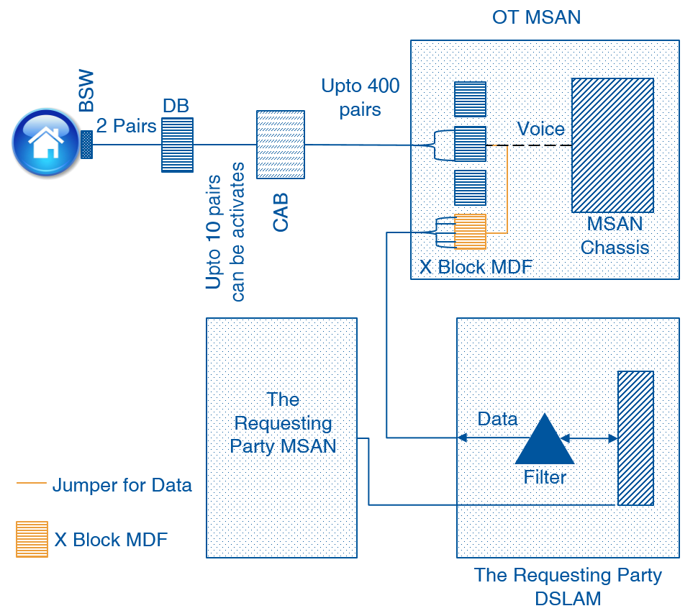
Figure ‎3-1 Local Loop Unbundling (MSAN outside the exchange)
      - The Requesting Party shall place its DSLAM adjacent to Omantel’s MSAN;
      - The Requesting Party shall request at least one MDF Strip in Omantel’s MSAN. This Strip will be used as a primary strip for the Requesting Party connection.
      - The Requesting Party shall extend its cable to Omantel’s MSAN and terminate it into the MDF Strip requested. The Requesting Party shall ensure that no cable/pairs hang out in the MSAN. This means that the Requesting Party shall extend the exact number of pairs that will terminate in the strip on the day of request.
      - Upon receiving the request to connect a Customer, Omantel will connect a cable (jumper wire) between the requested point on the primary strip requested by the Requesting Party and the secondary strip that has connectivity to the specified Customer.
      - In this case, the Customer access is shared and connected with Omantel MSAN and the Requesting Party DSLAM. This will allow the Requesting party to offer the data Services to the Customer while his voice continues to be served through Omantel.
      - The Requesting Party will be responsible for all required permits to place its DSLAM and extend the connection between its DSLAM and Omantel’s MSAN.
      - The Requesting Party shall be responsible for the provision of appropriate MDF Tie-cables between Omantel’s MSAN and Operator’s DSLAM.
      - The Requesting Party shall be responsible for the installation of ducts required to pull the Tie-cables and the termination of the copper pairs on each end of the Tie-cable.
      - The Requesting Party will be responsible for its own Power connectivity to its DSLAM.
    - For MSANs inside Omantel exchanges, the Service will be offered as described in diagram Figure ‎3-2 below and based on the following condition:
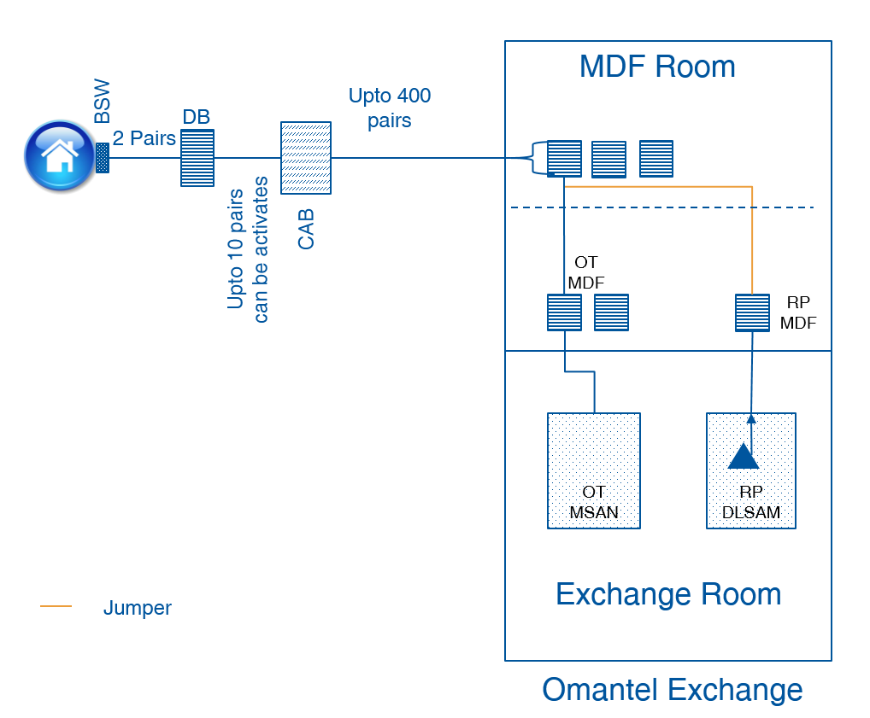

Figure ‎3-2 Local Loop Unbundling (MSAN inside the exchange)
      - The Requesting Party shall request a co-location Service from Omantel as described in Sub Annex C-FA 04. The Requesting Party shall co-locate its DSLAM and MSAN and its MDF at the co-location space.
      - Upon receiving the request to connect a Customer, Omantel will connect a cable (Jumper wire) between the Requesting Party’s MDF and Omantel’s MDF that has connectivity to the specified Customer.
      - The Customer access is shared and connected with Omantel’s MSAN and the Requesting Party’s DSLAM. This will allow the Requesting Party to offer the data Services to the Customer while voice service is through Omantel.
  - For MSANs not inside Omantel exchanges or on the street outside the exchange, the Service provisioning scenario shall be evaluated upon the Requesting Party request.

Terms and Conditions
  - Service Provisioning:
    - The Local Loop Unbundling Line Sharing provision shall be subject to technical feasibility.
    - The Local Loop Unbundling Line Sharing will be offered in locations where Omantel has the end to end connectivity to the Customer’s premises.
    - Omantel shall offer the Local Loop Line Sharing Service to those Customers who have paid in full their outstanding dues for Services acquired from Omantel.
    - Omantel shall remain the owner of the Local Loop. The Requesting Party shall not assign, transfer, lease, sell, resell or share their interest with any Third party Operator.
    - Omantel will be responsible to maintain the Local Loop and shall ensure that the Services offered to the Requesting Party are at the same level of quality as those to Omantel’s own Customers.
    - The number of MSAN connectivity should be distributed equally among all Regions at any given time.
    - Omantel shall be responsible to invoice the Customer for the voice Service only and collect the outstanding dues from its Customers.
    - Omantel shall not be responsible for any work within the boundary of the Customer premises.
    - Omantel shall not be responsible of the quality of the Service offered by the Requesting Party to the Customer through Omantel Local Loops due to the local loop length.
    - The broadband Service to be provided by the Requesting Party shall be based on the condition of the copper to be unbundled. Omantel shall not modify its copper network to provide a higher bandwidth beyond or above prequalified capacity of the copper pair to be unbundled.
  - The Requesting Party Responsibility:
    - The Requesting Party shall submit with its Local Loop Line Sharing request a copy of the Customer’s application form duly completed and signed by the Customer. The request shall contain all necessary information about the Customer including but not limited to, the Customer details, the bandwidth requested, the connectivity points and his connectivity requirement. The Requesting Party shall also provide a “No objection” letter from the former Service provider (Third Party Operator or Omantel) in case if the Customer is an active customer.
    - The Requesting Party shall be responsible for the availability and quality of the Service offered to its Customer.
    - The Requesting Party shall be responsible to invoice the Customer for the Data Service and collect the outstanding dues from its Customers.
    - The Requesting Party shall pay Omantel the charges specified in Clause ‎7 below even if the Customer has not paid his dues to the Requesting Party.
    - The Requesting Party shall setup a call center to address all Data Service complaints from the Customer.
  - Changing Location:
    - All changes to the location of the Local Loop will be considered a termination of the Service and an Order of a new one.
  - Contract Terms and Termination:
    - MSAN to DSLAM Connectivity:
      - The minimum Contract Term of the MSAN to DSLAM connectivity is three (3) Years.
      - If either Party wishes to terminate the Contract after the completion of the Contract Term, it shall inform the other Party, in writing, three (3) months before the completion of Contract Term, of its intent to terminate the Contract. The Requesting Party shall be responsible of the consequence he Requesting Party shall be responsible of the consequence if it terminated this Service with active Customer on his network.
      - If no notice is provided at least three (3) months before the completion of Contract, the Contract will be automatically renewed for the same Contract Term.
    - Local Loop Connectivity:
      - The minimum Contract Term of the Customer Local Loop is one (1) Year.
      - If either Party wishes to terminate the contract after the completion of the Contract Term, it shall inform the other Party, in writing, one (1) month before the completion of Contract Term, of its intent to terminate the Contract.
      - If no notice is provided at least one (1) month before the completion of Contract, the Contract will be automatically renewed on monthly rolling basis.
    - Omantel has the right to terminate the Service with immediate effect in case the Requesting Party is in breach of its obligation under this Agreement and the Requesting Party shall be responsible of all consequences of this act.
    - Termination of the Service by the Requesting Party before the expiration of the Contract Term is subject to an early Termination Fee equal to the charges of the remaining period of the Contract Term.
    - The Requesting Party can terminate the Contract upon the request from the Customer without the Termination Fee if the Customer requested the Service from Omantel directly or through any Third Party Operator.
    - The termination will be in accordance with the procedures in Annex H.

Database
  - Omantel will install and keep updated a database consisting of all active and ordered Local Loops. The database will consist of at least the following parameters:
- Customer Name
- Customer contact number
- Customer address
- Services subscribed
- Bandwidth requested
- order date
- agreed and promised delivery date
- actual delivery date
- reported faults
- maintenance actions taken
- installation fee
- monthly fee
- discount schemes applicable to the line if any
  - The Requesting Party shall keep updated a database consisting of all active and ordered Local Loops. The database shall contain all necessary information that will allow both Parties to reconcile accounts for charging purposes.

Ordering and Delivery
  - Ordering and delivery is handled according to Annex H in addition to the following Clauses.
  - With respect to connectivity between the Requesting Party DSLAM and Omantel MSAN, Omantel shall use its best endeavors to have a target delivery time of 15 Working Days and shall not exceed 30 Working Days subject to feasibility. However, in case more than one DSLAM connectivity is requested during the same period, the Parties shall negotiate and agree on an implementation plan.
  - The Requesting Party shall request the Local Loop Line Sharing of only those Customers who are connected to Omantel’s MSAN that is already connected to the Requesting Party’s Network.
  - With respect to Local Loop Line Sharing Order, Omantel shall use its best endeavors to have a target delivery time of 10 Working Days with a maximum delivery time of 20 Working Days subject feasibility.
  - The Requesting Party in respect the Local Loop Line Sharing orders may only request the Service once every two (2) weeks on a week day agreed between both Parties. Both Parties shall agree on the number of connections the can be submitted at each time.
  - Omantel’s technicians jointly with the Requesting Party’s technicians shall connect and test the Local Loop Line Sharing of the Customer.
  - The Requesting Party’s Network should be ready with the Service provisioning to the Customer before Omantel and the Requesting Party teams jointly connect the Customer. This will ease testing the Service.
  - If Omantel rejects the Requesting Party request, Omantel shall inform the Requesting Party of the reasons.

Tariff
  - The up to date tariff for the Services can be found in Annex M.
  - The cost of additional products features, specialized billing, systems and/or network interfaces, non-standard connectivity and associated configuration, integration and testing are not included in the published tariffs. Such cases will be dealt with on a case-by-case basis against mutual agreed timelines and charges.

Fault Management
  - Fault Management is handled according to Annex H in additional to the following Clauses.
  - The Requesting Party to carry out the initial tests in respect of any fault in Customer connection in order to validate that the fault is not from the Requesting Party Network. In case the fault is not at the Requesting Party Network, the Requesting Party shall make available all reasonable and complete test details when reporting the fault to Omantel.
  - In case no fault is found from Omantel’s side, the Requesting Party shall compensate Omantel for all costs to investigate the fault.

Forecasts
  - Forecasting shall be handled according to Annex F.

