1. Commercial Proposal for
Reference Access and Interconnection Offer Sub Annex C-FA 03 Local Loop Unbundling (Sub Loop Unbundling)

Table of Contents

1 General 3
2 Definition 4
3 Sub Loop Unbundling 5
4 Terms and Conditions 7
5 Database 10
6 Ordering and Delivery 11
7 Tariff 12
8 Fault Management 13
9 Forecasts 14

General
  - This Sub Annex sets out the Omantel offer for Sub Loop Unbundling Service.
  - Omantel through this fixed wholesale access Service will enable the Requesting Party to access Customer location through Omantel’s existing copper connectivity to the Customer premises.

Definition
  - The definitions in Annex L shall apply to this Sub Annex in addition to the following definitions:
    - Cabinet - Telecommunications device that gathers multiple Customers’ telephone lines and connects them to the core Network to provide voice and data Service.
    - Contract Term – the contract period of the Service provisioning starting from the Service provisioning date.
    - Region – is the Region in the Territory defined by the Authorities.
    - Sub Loop – the copper connectivity between the Customer premises to the closest Omantel Cabinet.
    - Strip – Multiple number of strips that composes a Cabinet. Each strip can connect up to 10 Customer.
    - Sub Loop Unbundling – form of Local Loop Unbundling where a sub-section of the Customer’s local copper loop in Omantel’s Network is disconnected from the rest of Omantel’s Network and permanently connected via a co-located Point of Access to the Requesting Party’s Network at the Cabinet

Sub Loop Unbundling
  - Omantel offers the Requesting Party the possibility to access the Customer premises using Omantel’s existing copper pairs.
  - The purpose of this Service is to enable the Requesting Party to offer Services to the Customers in Oman for their connectivity needs with the Territory.
  - The Omantel copper pair will be disconnected from Omantel’s Cabinet and reconnected to the Requesting Party’s cable.
  - The Service will be offered as described in Figure ‎3-1 below:
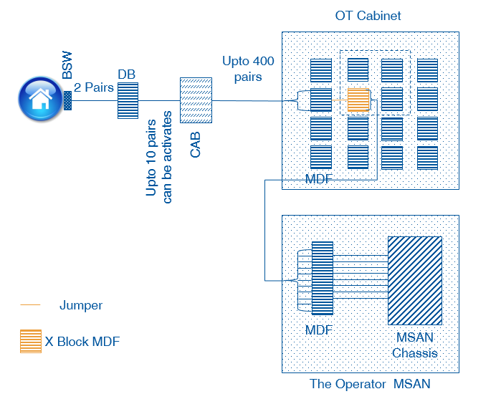
Figure ‎3-1 Sub Loop Unbundling
  - The Requesting Party shall place its MSAN adjacent to Omantel’s Cabinet.
  - The Requesting Party shall request at least one strip in the Omantel Cabinet. This strip will be used as a primary strip for the Requesting Party connection.
  - The Requesting Party shall extend its cable to Omantel Cabinet and terminate it into the strip requested. The Requesting Party shall ensure that no cable/ pairs hang out in the Cabinet. This means that the Requesting Party shall extend the exact number of pairs that will terminate in the strip on the day of request.
  - Upon receiving the request, Omantel will connect a cable (jumper wire) between the requested point on the primary strip requested by the Requesting Party and the secondary strip that has connectivity to the specified Customer.
  - In this case, the Customer access is fully separated from Omantel Cabinet and disconnected from its core Network. Omantel will not be entitled to provide any other Service to the Customer.
  - The Requesting Party will be responsible for all required permits to place its MSAN and extend the connection between its MSAN and Omantel Cabinet.
  - The Requesting Party shall be responsible for the provision of appropriate MDF Tie-cables between the Omantel and Operator MSANs.
  - The Requesting Party shall be responsible for the installation of ducts required to pull the Tie-cables and the termination of the copper pairs on each end of the Tie-cable.
  - The Requesting Party will be responsible for its own Power connectivity to its MSAN.

Terms and Conditions
  - Service Provisioning:
    - The Sub Loop Unbundling provision shall be subject to feasibility.
    - The Sub Loop Unbundling will be offered in locations where Omantel has the end to end connectivity to the Customer’s premise.
    - Omantel shall offer the Sub Loop of those Customers who have paid in full their outstanding dues for Services acquired from Omantel.
    - Omantel shall remain the owner of the Sub Loop. The Requesting Party shall not assign, transfer, lease, re-sell, or share their interest with any Third Party Operator.
    - Omantel will be responsible to maintain the Sub Loop and shall ensure that the Services offered to the Requesting Party are at the same level of quality as those to Omantel’s own Customers.
    - The number of MSAN connectivity should be distributed equally among all Regions at any given time.
    - Omantel shall not be responsible for any work within the boundary of the Customer premises.
    - Omantel shall not be responsible for the quality of Service offered by the Requesting Party to the Customer through Omantel Sub Loop due to the Sub loop length.
    - Any Service that will be provided by the Requesting Party shall be based on the condition of the copper to be unbundled. Omantel shall not modify its copper network to provide a higher bandwidth beyond or above prequalified capacity of the copper pair to be unbundled.
  - The Requesting Party Responsibility:
    - The Requesting Party shall submit with its Sub Loop request along with a copy of the Customer’s application form duly completed and signed by the Customer. The request shall contain all necessary information about the Customer including but not limited to, the Customer details, the connectivity points and his connectivity requirement. The Requesting Party shall also provide “No objection” letter from the former Service provider (Third Party Operator or Omantel) in case if the Customer is an active customer.
    - The Requesting Party shall be responsible for the availability and quality of the Service offered to its Customer.
    - The Requesting Party shall be responsible to invoice and collect the outstanding dues from its Customers.
    - The Requesting Party shall pay Omantel the charges specified in Clause ‎7 below even if the Customer has not paid his dues to the Requesting Party.
    - The Requesting Party shall setup a call center to address all complaints from his Customers.
  - Changing Location
    - All changes to the location of the Sub Loop will be considered as a termination of the Service and an Order of a new one.
  - Contract Terms and Termination:
    - Cabinet to MSAN Connectivity:
      - The minimum Contract Term is three (3) Years.
      - If either Party wishes to terminate the contract after the completion of the Contract Term, it shall inform the other Party, in writing, three (3) months before the completion of Contract Term, of its intent to terminate the Contract. The Requesting Party shall be responsible of the consequence he Requesting Party shall be responsible of the consequence if it terminated this Service with active Customer on his network.
      - If no notice is provided at least three (3) months before the completion of Contract, the Contract will be automatically renewed for the same Contract Term.
    - Sub Loop Connectivity:
      - The minimum Contract Term is one (1) Year.
      - If either Party wishes to terminate the contract after the completion of the Contract Term, it shall inform the other party, in writing, one (1) month before the completion of Contract Term, of its intent to terminate the Contract.
      - If no notice is provided at least one (1) month before the completion of Contract, the Contract will be automatically renewed on monthly rolling basis.
    - Omantel has the right to terminate the Service with immediate effect in case the Requesting Party is in breach of its obligation under this Agreement and the Requesting Party shall be responsible of all consequences of this act.
    - Termination of the Service by the Requesting Party before the expiration of the Contract Term is subject to early Termination Fee equal to the charges of the remaining period of the Contract Term.
    - The Requesting Party can terminate the contract upon the request from the Customer without the Termination Fee if the Customer requested the Service from Omantel directly or through any Third Party Operator.
    - The termination will be in accordance with the procedures in Annex H.

Database
  - Omantel will install and keep updated a database consisting of all active and ordered Local Loops. The database will consist of at least the following parameters:
- Customer Name
- Customer contact number
- Customer address
- Services subscribed
- order date
- agreed and promised delivery date
- actual delivery date
- reported faults
- maintenance actions taken
- installation fee
- monthly fee
- discount schemes applicable to the line
  - The Requesting Party shall keep updated a database consisting of all active and ordered Local Loops. The database shall contain all necessary information that will allow both Parties to reconcile accounts for charging purposes.

Ordering and Delivery
  - Ordering and delivery is handled according to Annex H in additional to the following Clauses.
  - With respect to connectivity between the Requesting Party MSAN and Omantel Cabinet, Omantel shall use its best endeavors to have a target delivery time of 15 Working Days and shall not exceed 30 Working Days subject to feasibility. However, in case if more than one MSAN connectivity is requested during the same period, the Parties shall negotiate and agree on an implementation plan.
  - The Requesting Party shall request the Sub loop of only those Customers who are connected to Omantel Cabinet that is already connected with the Requesting Party Network.
  - With respect to Local Loop Order, Omantel shall use its best endeavors to have a target delivery time of 10 Working Days with maximum delivery time of 20 Working Days subject to feasibility.
  - The Requesting Party in respect the Local Loop orders may only request the Service once every two (2) weeks on a week day agreed between both parties. Both Parties shall agree on the number of connections that can be submitted at each time.
  - Omantel’s technicians jointly with the Requesting Party’s technicians shall connect and test the Sub Loop of the Customer.
  - The Requesting Party’s network should be ready with the Service provisioning to the Customer to before Omantel and the Requesting Party teams jointly connect the Customer. This will ease testing the Service.
  - If Omantel rejects the Requesting Party request, Omantel shall inform the Requesting Party on the reasons.

Tariff
  - The up to date tariff for the Services can be found in Annex M.
  - The cost of additional products features, specialized billing, systems and/or network interfaces, non-standard connectivity and associated configuration, integration and testing are not included in the published tariffs. Such cases will be dealt with on a case-by-case basis against mutual agreed timelines and charges.

Fault Management
  - Fault Management is handled according to Annex H in additional to the following Clauses.
  - The Requesting Party shall carry out the initial tests in respect of any fault in Customer connection in order to validate that the fault is not from the Requesting Party Network. In case the fault is not at the Requesting Party Network, the Requesting Party shall make available all reasonable and complete test details when reporting the fault to Omantel.
  - In case no fault is found from Omantel’s side, the Requesting Party shall compensate Omantel for all costs to investigate the fault.

Forecasts
  - Forecasting shall be handled according to Annex F.

